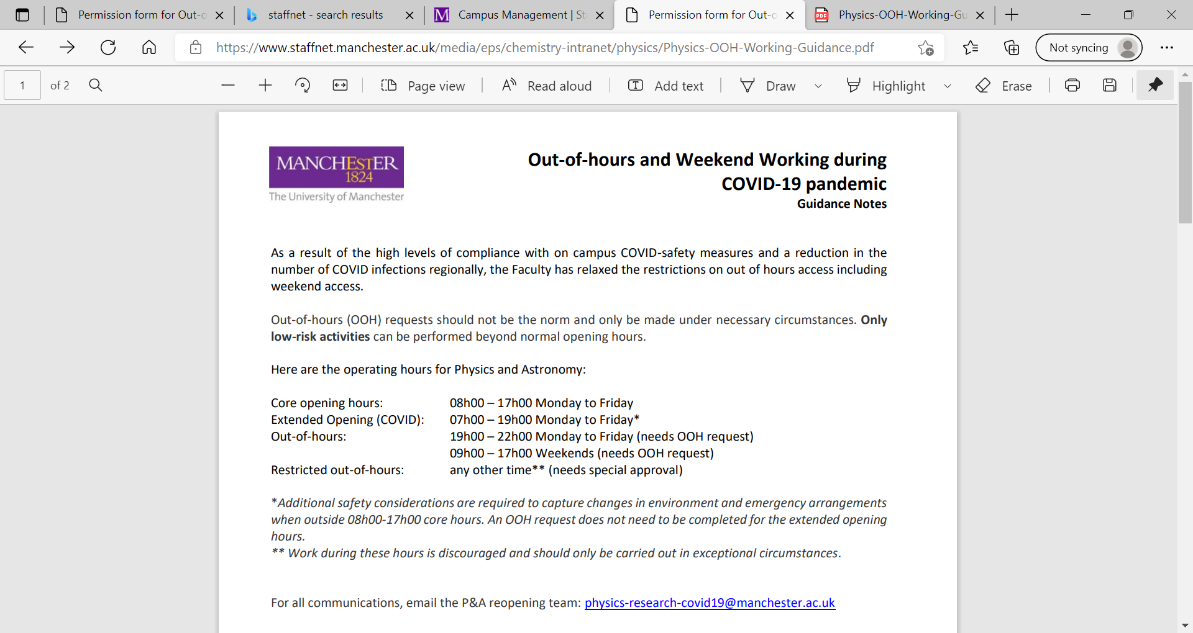

**Physics and Astronomy Out-of-hours and Working**

Extended opening* and restricted out of hours** (OOHs) including weekend working must be signed by your supervisor/line manager and confirms that they have reviewed the risk assessment and are satisfied that out-of-hours risks or out of hours/lone working risks have been suitably addressed, and that this work cannot be rescheduled to be completed during normal working hours. Only low-risk activities can be performed beyond core opening hours.

**Here are the operating hours for Physics and Astronomy:**

* Core opening hours: 08h00 – 18h00 Monday to Friday
* Extended Opening: 06h00 – 22h00 Monday to Sunday* (request to Phys Ops)
* Restricted 24 hour Out-of-hours: 22h00-06h00 Monday to Sunday (needs HoD approval and OOH request to Phys Ops)**

* An OOH working or OOH lone working risk assessment is required (not core opening hours); as additional safety considerations are required to capture changes in environment and emergency arrangements.

** Work during these hours is discouraged and should only be carried out in exceptional circumstances. These requests are subject to the HoD approval and are time restricted.

**Out-of-hours Procedure**

1. Read and complete the [Out of Hours Risk Assessment](https://www.staffnet.manchester.ac.uk/media/eps/chemistry-intranet/physics/Physics-Out-of-hours-(OHH)-RA.docx) for the above criteria. (Edit / update the parts highlighted in yellow with full detail of the activities that are taking place).

2. If the work involves out of hours lone working, read and complete the [Out of Hours Lone Working Risk Assessment](https://www.staffnet.manchester.ac.uk/media/eps/chemistry-intranet/physics/Physics-Out-of-hours-and-lone-working.docx). (Edit / update the parts highlighted in yellow with full detail of the activities that are taking place.)

3. Ensure your supervisor/line manager has signed off and are satisfied that the risks have been suitably addressed.

Notes:

* Ideally, two users should be working in the area at once in order to avoid lone working.
* The risk assessment(s) must be completed by each individual.
* All aspects of any proposed OOH work or OOH lone working must be risk assessed before any work commences.

Postgraduate students and PDRAs must first speak to their line manager/supervisor. The PI or line manager must decide if these activities can take place safely during out of hours.

* PIs and line managers are responsible for the health and safety of their activities and researchers. They must ensure that all members of their team when on campus achieve good practice and high levels of compliance for all aspects of health and safety.
* No extended opening, weekend or restricted OOH access is permitted for UG students. Exceptions are made on a case by case basis to the HoD.

Following Approval

A copy of the risk assessment(s) must be kept near the person, ready to be shown to staff checking the building.

For access to campus during the restricted 24 hour out-of-hours, permission must be requested on an individual access basis through the Phys Ops. The PI and worker must email Phys Ops to request such an access, approval will also be required through the Head of Department.

Non-compliance with health and safety measures will result in disciplinary action highlighted in the Department H&S policy.

Lone Working Guidance

A lone worker is anyone at any time that has no immediate audible or visual contact with a second person able to provide assistance in the case of emergency. Generally, this applies to out-of-hours working, but may also apply during normal working hours when a person is working within an internal lab with no vision panel. In situations where a person may be lone working, the risk assessment must clearly state what measures are in place to ensure the persons safety. This may include ensuring that other group members know where the person will be working (and for how long), having designated check in times (and investigating if the check in is missed).