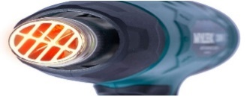
Safe Use of Heat Guns
What are heat guns or hot air guns?  A heat gun is a tool used to apply heat directly to objects. They come in a wide range of sizes and power ratings.  Heat guns use thermal conduction (the transfer of energy due to temperature differences) rather than convection or radiation like an oven does; they work by blowing air over an element that produces infrared radiation which then passes directly into the object it is directed at.  Heat guns are frequently used in laboratories and workshops.  What are the hazards?  The heating element in a heat gun typically becomes extremely hot during use; however, the lack of a visible flame can create a false sense of security or false impression of safety and while the danger zone is invisible, it is very active.  The combination of sparks and forced ventilation over a glowing filament may lead to fire and/or explosion if left unattended or used incorrectly. Heat guns operate at lower air speeds and produce temperatures as high as 650 ⁰C, hot enough to melt some types of glass. The power switches and fan motors are not usually spark-free and can pose a serious ignition hazard. | Keep the following in mind when using a heat gun:  Do not use a heat gun near combustible, flammable or pressurised materials.  Always be aware of the direction of the heat.  Always switch the heat gun off before putting it down on a heat resistant surface. Unplug the heat gun when not in use.  Allow the tool to cool before storing it.  Always maintain a least 1 cm of clearance between outlet nozzle and work surface.  Never touch the hot metal nozzle with clothing or skin or direct the air flow towards one’s body.  Do not look down the nozzle while the gun is on.  Never block the inlet grill or obstruct the air flow of the unit while in operation.  Do not use an extension cord to power a heat gun because a high current draw can result in overheating and pose risk of fire or electrocution.  Never hold a sample without forceps or other suitable devices while using a heat gun or you will risk direct exposure of the heat to your hand. | Before using a heat gun ensure that you have read and signed the risk assessment. An example heat gun RA can be found the Physics intranet.  Incident learning and sharing:  - Heat gun fire in a lab. The lab was unoccupied at the time of the fire. Had the heat gun been unplugged, the fire would have not occurred.  - Heat Gun Ignites a Wash Bottle. A heat gun, which had been recently used and was hot, was set down in close proximity to a wash bottle. The solvent within the wash bottle ignited causing a fire.  - Heat gun ignites paper. Paper towels were in close proximity to the operation. The heat from the heat gun ignited the paper, which quickly spread to nearby solvents, exaggerating the fire.  - Burn to hand: A student accidently touched a heat gun nozzle that had been placed down at the front of a bench. They had not realised it had recently been used and was hot.  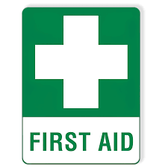  If burns occur, run affected area under a cold tap for at least 10 mins, call a first aider, burn dressings for heat burns are in the first aid box.

