**Task/ Work:** Use of Ekspla NT342B Laser and Edinburgh Instruments LP980 Transient Absorption Spectrometer

**Location (Room/ Building):** Lab 001, Building A

**Date :** X/Y/ZZZZ

**Reference / Version :** V1

**Review Date :** Annually, or at change of use

**University Laser Safety Officer :** Dr Ian Haslam, ian.haslam@manchester.ac.uk

**Local Laser Safety Advisor :** laser safety advisor’s name

**Issued under the authority of :** PI/Lab manager’s name

**Purpose & Scope**

This document describes safe working procedures, the use of controls identified in the risk assessment, and plans for any reasonably foreseeable incidents. This document covers the normal use and user maintenance operations of the transient absorption spectrometer located in Lab 001, Building A. Instrumentation includes an Ekspla NT342B Nd:YAG and integrated OPO and an Edinburgh Instruments LP980 spectrometer. This document implements the University’s laser safety policy at a practical level and form part of the University’s duties under Section 2(3) of the Health and Safety at Work etc Act 1974.

**Introduction & Description of Lasers**

Class 4 laser: Ekspla NT342B laser, comprising a Q-switched Nd:YAG laser and optical parametric oscillator (OPO) with second harmonic (SH) generation in one compact housing. Outputs, at a 10 Hz repetition rate, with beam diameter of ~5 mm, are: 355 nm (5-7 ns pulse duration, 100 mJ / 1 W); OPO signal 410 – 710 nm (3-5 ns pulse duration, <34 mJ), SH-OPO output 210 – 410 nm (3-5 ns pulse duration, <7.5 mJ). Not used: OPO idler 710 – 2600 nm (3-5 ns pulse duration, < 11 mJ).

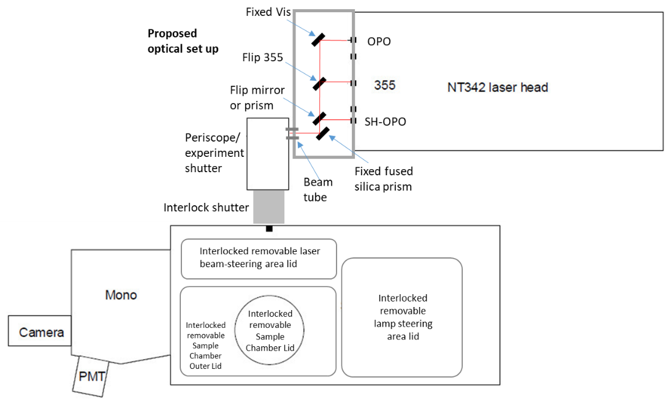The laser outputs are directed to the spectrometer via fixed height steering mirrors. The optics are contained in a black anodized aluminium enclosure. The beams from this enclosure are directed via short (<5 cm) beam tube into a fully enclosed periscope which directs the beam via a shutter into the spectrometer.

The LP980 transient absorption spectrometer which has a number of accessories including a TgK stopped–flow (rapid mixing) and Oxford instruments cryostat which fit with custom-fitted lids to the sample chamber.

If all covers are in places there are no open beams.

**Justification for Open Beam Work**

All beams are enclosed during normal use. Open beam work is only undertaken for very infrequent alignment / maintenance purposes (0-4 times/year), and only by highly trained personnel. The optics require complex (multi-axis) fine adjustments which cannot be automated due to insufficient space in this commercially produced system.

There are limited possible procedures, which are detailed in this document, which aims to provide strict guidance on the best practice during this work to reduce risks. Open beam work will only take place during normal working hours (i.e. 8 am to 6 pm, Monday - Friday).

**Authorised Users / Responsibilities**

Only persons who are adequately trained in the safe operation and authorised as listed in the appendix to these local rules may operate the spectrometer and laser. All users must have undergone the formal safety and procedural training which is required to operate the experiment safely as listed on the Laser Safety Management Form LS3, Induction and Training Checklist, including attending the Laser Safety Awareness course (THS42e). Only Senior Technical Specialist #1 and or Senior Technical Specialist #2 may remove fixed enclosure covers or carry out any open beam work (i.e. adjust any of the optics and carry out user maintenance), they have received further training and completed the Advanced Laser Safety Course (THS43e).

**Laser Controlled Area**

The experiment resides in Lab 001, Building A. Access to the room is controlled by a coded entry system from the corridor. There is an illuminated sign above the outside of the door which is to be switched on whenever the laser is on. If any beam routing or other optical manipulation occurs which involves the removal of the enclosure covers or beam tubes then a chain, with a DANGER Open Laser Beams KNOCK & WAIT“ sign is placed across the doorway.

**Protection Measures / PPE**

An interlock key switches is provided on the laser power supply. When the power supply interlock key switch is in the ‘ON’ position laser radiation can be produced. The appropriate use of this key remains the direct responsibility of the operator. The key must not be left at any time in the possession of anyone who is not named on the authorised access list. When not in operation, the key is kept in the lab key safe, the code for which is only in the possession of authorised users.

During normal operation the beam is fully enclosed in metal enclosures. The laser headcover is interlocked. The beam routing enclosure and periscope mount/cover are screwed in place, the enclosure lid is secured with security screws. The experimental case has a number of removable lids which are interlocked to a shutter between the periscope and spectrometer. All access lids are labelled with appropriate warning signs.

The emission from any of the lasers described above should be considered extremely hazardous at all times. The accompanying risk assessment and safety calculation documents describe the laser safety calculations performed to assess the associated health risks, specifically the maximum permissible exposure (MPE) according to PD IEC TR 60825-14:2022, and the Exposure Limit Value (ELV) according to Annex II of Directive 2006/25/EC, and laser safety google scale numbers (LB) according to BS EN 207:2017.

Laser glasses are to be checked prior to use for cleanliness and scratches, a summary of requirements and available PPE is as follows:

|  |  |  |  |  |
| --- | --- | --- | --- | --- |
|  | Max. energy | Requires | Available NoIR DBY and ARG glasses cover: | **Energy Limit** |
| **355 nm**  **(pump)** | 100 mJ | RLB7 (DLB5) | RL6 (DL4) | **153 mJ** |
| **210 – 315 nm (SH output)** | <7.5 mJ | DLB8 (RLB2) | DL7 (RL4) | **3.1 mJ** |
| **315 – 400 nm (SH output)** | <7.5 mJ | RLB5 (DLB4) | RL6 (DL4) | **-** |
| **410 – 710 nm (OPO signal)** | <30 mJ | RLB7 (DLB4) | 400 – 534 nm RL6 (DL5) | **400 – 534 nm 5 mJ** |

The OPO Idler signal (710 – 2600 nm) is not used.

**NO OPEN BEAM WORK TO TAKE PLACE: 534 – 920 nm**

Whenever open beam work is being conducted with this system the appropriate goggles must be worn by all users present.

**Procedures**

Before starting the laser system the operator must be fully trained in its use by Senior Technical Specialist #1, and have read, understood, and signed the scheme of work and risk assessments relating to the activity being undertaken. The user must inspect all the laser safety protections implemented.

There are 2 main types of operation which may need to be carried out.

**1. Normal operation where data is being collected**.

• All laser head and PSU covers must be in place with no interlocks overridden.

• All beam covers must be in place.

• Light above door switched on.

• If the output of the laser needs to be switched between 355 nm and the OPO or SH-OPO output then Senior Technical Specialist #1 or #2 should be contacted.

• The laser and spectrometer are both controlled by the PC, no other controls should be adjusted. Only the lid of the sample compartment should ever be opened, and that only to exchange samples when the laser is not firing

**2. Alignment of open laser beam** – Only by Senior Technical Specialist #1 or #2

• In addition to the Laser light above the door the chain and “DANGER Open Laser Beams KNOCK & WAIT“ sign is placed across the doorway.

• The laser should not be left unattended in an open-beam state or when turned on and enclosure interlocks defeated.

• The operator must ensure that no other persons are present in the laser area other than those strictly required for the purpose in hand.

• Anybody in the area must wear laser protective eyewear conforming to BS EN207, as defined in the risk assessment, unless the operator has confirmed that all protective beam covers are correctly installed.

• The user who starts the laser system is responsible for ensuring the system is turned off after experiments are concluded.

• Reflective items such as rings and watches must be removed before any optic manipulation takes place.

• The operator must at all times be aware of the location of all beam paths.

• The lowest practical laser power must be used at all times, and optics alignment should only be conducted at 350 – 450 nm. Laser power can be attenuated within the laser using software control, or additional ND filters may be placed (when laser is enclosed) outside laser output.

• Optics should be checked for damage and stability before open beam work is carried out

• The procedures for use of the laser are detailed in the relevant section of the instructions manuals stored on a shelf in the corner of LG.045a.

• The operator must ensure that after open beam work takes place all safety covers and interlocks are restored.

• When adjusting optical paths a beam block should be placed at the output of the laser to be aligned before the laser is switched on. The laser can then be switched on and the position of the beam spot verified. The laser shutter should then be closed, and the beam block moved just beyond the next optical element. The shutter should then be opened again, the beam pointing checked on the next optic, and any necessary adjustments made. It is essential to ensure the beam is fully stopped by the beam block while performing this. This sequence should be repeated with each optical element, making small adjustments to the alignment as necessary. Note – the periscope should never be aligned in this way (with any open beams).

**Summary of Hazards**

• Class 4 beam hazards – Laser radiation from a Class 4 laser is extremely hazardous to the eyes and skin. The laser beam, as well as its specular and diffuse reflections must not be viewed at any time.

• High voltages in laser head and PSU, and on PMT

• Water cooling

• Trip hazards.

• Chemicals

• Cryogenic samples

• Electrical hazard from ancillary equipment.

**Contingency Plan**

In case of emergency call your nearest first aider, outside of normal working hours call Security on 0161 306 9966.

If an ambulance is needed, telephone 999 stating clearly the full postal address (XXX), and what is wrong with the casualty, together with your name. Also inform building reception (XXXX) and arrange for somebody to meet and direct the ambulance staff to the casualty.

In the event of an accident involving eye exposure, as soon as possible and within 24 hours of the incident, take this completed card and any relevant risk assessments to:

**Manchester Royal Eye Hospital, Oxford Road, Manchester, M13 9WL**

Emergency Eye Department opening times: 08:00-20:00, 7 days a week

Outside these hours call: 0161 701 0249, or attend general A&E at Manchester Royal Infirmary (address as above)

Do not drive yourself. Get a friend or colleague to take you, or use a taxi.

It is important that the affected person does not rub their eye after exposure as this can lead to corneal abrasions.

All injuries, however small, and any near-misses must be reported to the Local Safety Advisor in order that an accident form or near miss form may be completed.

In the event of any unsafe condition or fault being apparent with the equipment, the experiment must cease immediately, the laser be turned off if it is safe to do so, and the matter reported to local staff supporting the experiment.

**Scheme of Work Approved by:**

Name: ………………………… Signature:………………………… Date:…………

**THIS DOCUMENT SHOULD BE REVIEWED ANNUALLY**

**User Declaration**

*I have read and understood this document and agree to abide by its requirements at all times.*

*I understand that in the event of any malfunction, or suspected malfunction, of any part of the laser system or its security and safety systems that the experiment must be stopped immediately, the laser switched off and the matter reported to local staff supporting the experiment. I accept that we are all jointly responsible for one another’s safety and undertake not to knowingly permit the infringement of these Rules and Procedures by others.*

**Authorised Users**

**Name Signature PI Signature Date**

1 ……………………………………… ……………………………… ……………………………… ……………………

2 ……………………………………… ……………………………… ……………………………… ……………………

3 ……………………………………… ……………………………… ……………………………… ……………………

4 ……………………………………… ……………………………… ……………………………… ……………………

5 ……………………………………… ……………………………… ……………………………… ……………………

6 ……………………………………… ……………………………… ……………………………… ……………………

7 ……………………………………… ……………………………… ……………………………… ……………………

8 ……………………………………… ……………………………… ……………………………… ……………………

9 ……………………………………… ……………………………… ……………………………… ……………………

10 ……………………………………… ……………………………… ……………………………… ……………………

11 ……………………………………… ……………………………… ……………………………… ……………………

12 ……………………………………… ……………………………… ……………………………… ……………………

W_LASER1****

In case of emergency call your nearest first aider, outside of normal working hours call Security on 0161 306 9966.

If an ambulance is needed, telephone 999 stating clearly the full postal address (XXX), and what is wrong with the casualty, together with your name. Also inform building reception (XXXX) and arrange for somebody to meet and direct the ambulance staff to the casualty.

In the event of an accident involving eye exposure, as soon as possible and within 24 hours of the incident, take this completed card and any relevant risk assessments to:

**Manchester Royal Eye Hospital, Oxford Road, Manchester, M13 9WL**

Emergency Eye Department opening times: 08:00-20:00, 7 days a week

Outside these hours call: 0161 701 0249, or attend general A&E at Manchester Royal Infirmary (address as above)

Do not drive yourself. Get a friend or colleague to take you, or use a taxi.

It is important that the affected person does not rub their eye after exposure as this can lead to corneal abrasions.

|  |  |
| --- | --- |
| Laboratory Address: |  |
| Laser classification: |  |
| Type: Pulsed, Continuous Wave |  |
| Wavelength (nm) |  |
| Effects on Eyes of excessive exposure. | Delete as appropriate:  180 – 315 nm: Photokeratitis  315 – 400 nm: Photochemical cataract  400 – 780 nm: Photochemical and thermal retinal injury  780 – 1400 nm: Cataract, retinal burn  1400 – 3000 nm: Aqueous flare, cataract, corneal burn  3000nm – 1 mm: Corneal burn |
| Pulse energy (duration, peak power, repetition frequency) |  |
| Circumstances of accident / injury: |  |
| Time & Date of Injury |  |
| Eye affected: Left / Right / Both | |
| Were protective goggles being worn? Yes / No | |