Manual handling checklist – The Full Life Cycle
Purchasing of item
Does it require a CE mark or UKCA marking? Information for UKCA marking post Brexit here
Is a certificate of conformity required? Ensure this is agreed with the supplier before purchasing.
Does it require specialist installation and commissioning? You will need to liaise with the relevant TOM on this.

Reputable supplier? Only order from reputable suppliers to ensure what you order is what it states it is.

Is a COSHH form required? E.g., lead has health risks, magnesium could be a fire risk. A risk assessment may also be required and may need to contain some of the points below.

Consider the size of the item you are ordering, is there room to store it?
Will it fit through the doorways? Will it fit in the lift? Maximum load of the lift?
Any there any sharp edges, how heavy is it? Is it bulky?
Is it unstable or likely to move unpredictably?
Will mechanical aids be required?
Will there be a risk to Stores staff or anyone collecting it?
How will you move the item in to your own work area? What will be the full transport route?
Is it safe to move the item to this location, what other activities are occurring near-by and what is the potential impact?

Consider how the item will be disposed of at the end of its usable life.
Ensure all disposal procedures and regulatory needs are complied with.
Ensure the equipment is not offered outside of the University of Manchester.
If the item needs to be disassembled prior to disposal, how will this be done? Can it be done safely? Will specialists be needed?
Will the item need to be decontaminated? If so, how?

Design stage
Can the equipment be designed with lifting in mind?
If heavy, bulky, sharp edges or awkward to move can anything be added to the design of the equipment to make it easier to move or safer to use?

Can the equipment be designed with ergonomics in mind?
Consider the end users - how often will they be using this equipment, how easy is it to use, do you need to excessively stretch, reach, bend, stoop or twist to use, can it be designed differently to ensure the best natural posture can be used?
Is it being placed with space to allow for cleaning and maintenance?
Are essential parts, controls or services easily accessible?

If large can it be made so it can be moved in smaller manageable loads?
Can it be assembled easily or will specialists need to be involved?

Consider how the item will be disposed of at the end of its usable life.
Ensure all disposal procedures and regulatory needs are complied with.
Ensure the equipment is not offered outside of the University of Manchester.
If the item needs to be disassembled prior to disposal, how will this be done? Can it be done safely? Will specialists be needed?
Will the item need to be decontaminated? If so, how?

Manufacturing the equipment
How will the equipment be moved during construction/ assembly?
Will mechanical aids be needed? Is there enough space around your work area to do this safely?
Does it require fixing to the floor or wall, or other work that requests Estates?

Is the floor level and free from contaminants? Is there good lighting?
What PPE will be required? Is extraction required?
Is the correct power supply available?

How will it be manipulated, if adding heat or applying significant force etc., how will the relevant additional risk be managed?

How will waste materials be disposed of? Any risk to health, inhalation, cuts to hands etc. how will these be controlled?

Where will it be stored when completed? Is there space for the equipment once constructed?
How will it impact of nearby activities and vice versa?

Is any testing or commissioning of the equipment required before it can be sent to the end user?

Any information the end user needs to ensure it can be used safely.

End products – Handover to end users
Has the technical manager been notified of this new equipment?
Will it require adding to the insurance, maintenance or asset list?
Have all relevant safety documents been passed on to the end users?

A risk assessment is required for this process and must be signed off before the move takes place by the managers. Safety Advisors can provide guidance and support.

A generic manual handling risk assessment can be found here: https://www.staffnet.manchester.ac.uk/media/eps/chemistry-intranet/physics/Example-Manual-Handling-Risk-Assessment---Moving-Equipment.docx

The size, weight, shape, distance to be travelled, mechanical aids or people’s competency will determine if a specific risk assessment is required. See HSE manual handling low risk filters in Appendix 1 on p4 to determine this.

How will the equipment be moved?
Is their sufficient space throughout the journey for the equipment to be moved from location A to location B, and stored in the area where it is going to?
Does the equipment require specific infrastructure to be used safely? E.g. 3-Phase power supply, water for cooling.
Is the floor loading sufficient to be able to support the equipment?

Is a specialist mover required? If cranes and other lifting equipment are required, this can only be done by a trained and competent person who has extensive experience of this process.
Is the gantry crane maximum capacity, along with other safe working loads (SWL) suitable for this move? i.e. the SWL must not be exceeded.
Safe operation of lifting equipment must be included in the risk assessment.

Think - Load
Think weight, bulky, difficult to grasp, unstable, sharp objects.
Can it be broken down and moved in smaller manageable sections? This may require you to contact the manufacturer to ensure this is possible and does not invalidate your warranty.

Think - task
Does it require holding the load away from the body?
Twisting, stooping or reaching upwards?
Any large vertical movements?
What is the distance it needs to be moved?
Is any strenuous pushing or pulling required?
Does it involve moving between buildings, is their enough space on the route for it to move easily through doors, corridors, lifts to outside.
What is the floor like throughout the whole move, think loose paving slabs outside?
Any variation in floor level, steps?
Any obstacles, e.g. doors, sharp turns along a corridor?
When off-loading and assembling the equipment what will be required to do this safely?

Think - Environment
Hot or cold environments, lighting level inside and out.
Chance of strong winds, which would make the load unstable?
Restrictions in movement due to clothing or other PPE required. What PPE is required?
People, traffic and other activities taking place along the route and where the equipment is to be used.

Think - Individual
Who will be moving the equipment?
Are they competent at doing this?
Think of the strength and agility of the individual?
Do they have a physical and mental capacity to do this? e.g. bad back or inexperience
Any special information or training required in order to do this?
Does it require more than one person to lift/move?
Does it require someone to open hold doors?
Is a banks person needed?
If going outside is the route from people and vehicle traffic?
Can the move be done at a certain time to avoid busy periods where students and staff may be present?
COVID – can 2m social distancing be maintained throughout? If not can the time be reduced to no more than 15 mins? Side to side interactions favoured over face-face?

Think – mechanical aids
If mechanical aids required? Have pre-use checks occurred? Are they in good order? Is there a valid statutory inspection and maintenance record?
Is it the correct mechanical aid for the job?
If it has wheels, are they suitable for all terrains? Do the wheels move freely?
The handle of the mechanical aid should be between waist and shoulder height to avoid awkward postures, are the handle grips in good condition and comfortable to use?
Does it have brakes?
Do the brakes work?
Has a comprehensive pre-use check been carried out?

Forms:
Blank specific manual handling RA
Example RA - specific manual handling RA
Manual handling RA – use of trolleys

Appendix 1 - HSE manual handling low risk filters
Use simple filters below to distinguish low risk tasks where a specific RA would not be required.
Lifting and lowering risk filter
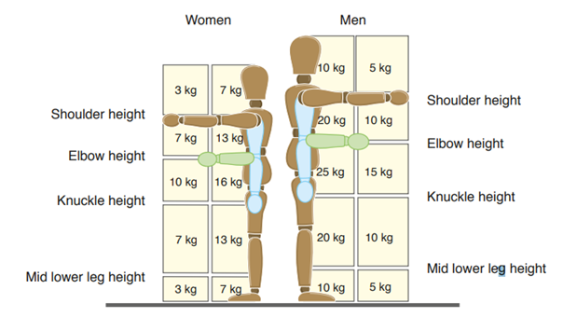
- Assume the load is grasped easily with both hands, is handled in reasonable working conditions and the worker in a stable body position.
- Use the zones below to determine where the worker’s hands pass through when moving the load and assess the maximum weight being handled.
- Where task falls within the filter guidelines, no need to do any other form of risk assessment unless individual workers at significant risk e.g. pregnant, with disabilities, after recent injury, inexperienced or temporary workers, lone workers or workers where English is not their first language.
- If outside this or the torso is twisted, more frequent than lifting every 2 mins, it’s a complex lift or its done by a team, you will need to do a more detailed specific assessment.
Carrying risk filter
- You can apply the filter weights for lifting and lowering in figure above to carrying operations where the load is held against the body;, carried no further than about 10 m without resting; does not prevent the person from walking normally; does not obstruct the view of the person carrying it; does not require the hands to be held below knuckle height or much above elbow height.
- Where you can carry the load securely on the shoulder without lifting it first (for example, by sliding it onto your shoulder), you can apply the filter values up to 20m
Pushing and pulling risk filter
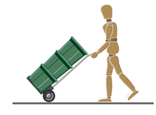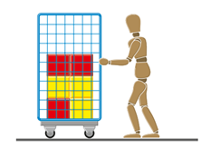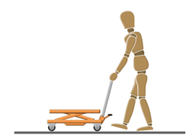
- In pushing and pulling operations, the load might be slid, rolled or moved on wheels.
- Observe the worker’s general posture during the operation. The figure above shows some acceptable push/pull postures.
- The task is likely to be low risk if: the force is applied with the hands; the torso is largely upright and not twisted; the hands are between hip and shoulder height; the distance moved without a pause or break is no more than about 20m.
- If the load can be moved and controlled very easily, for example with one hand, you do not need to do a more detailed assessment.
- You should make a more detailed assessment using, for example, the RAPP tool or full risk assessment checklists (or equivalent) if: the posture shows that the task requires significant forces, for example, leaning; there are extra risk factors like slopes, uneven floors, constricted spaces or trapping hazards.
Handling while seated
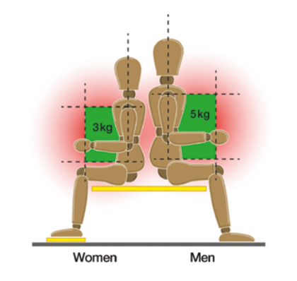
- The filter values for handling operations carried out while seated, as shown above are Men: 5 kg and Women: 3 kg. These values only apply for two-handed lifting and when the hands are within the green zone shown.
- If handling beyond the green zone is unavoidable, you should make a full assessment.

