FSE – Guidance on Personal Safety during Lone Working and Out of Hours
Julia Cheung
2022

Introduction

The University guidance on lone working defines it as “a person working without close or direct supervision and without contact from others. It can take place both out of hours and during the normal working day”.
It can involve any type of activities, including office work and practical work. It can also be planned into a work schedule, or unplanned. Examples of unplanned scenarios include working beyond normal hours unexpectedly, or other workers leaving the vicinity resulting in a person working alone.
While lone working, a person may encounter difficulties in summoning help quickly in an emergency. This risk applies to both inside and outside a building, weekday or out of hours. In addition, if lone working takes place during out of hours, a lone worker can be left more vulnerable, as the campus is quieter during evenings and weekends.
For these reasons, wherever possible, lone working should be avoided in the first instance. Where there is a real requirement for lone working, a suitable risk assessment should be completed, and the activities should be limited to low risk, such as desk work, computer work, and practical activities with low-risk rating from the risk assessment.
Out of hours working must be authorised by their line manager or academic supervisor beforehand.
It is common for lone working and out of hours risk assessments to be focused on the activity. It is important for a lone worker, their line manager or academic supervisor to recognise that personal safety is also extremely important and should form part of a robust risk assessment. The impact of work pressure on the worker’s physical and mental wellbeing should also be considered.
This guidance highlights elements of personal safety, wellbeing and changes in the environment that all lone workers should consider. It should be used in conjunction with University and local policies on lone working, and the On campus lone worker checklist.

 | Factors to consider
 | Lone working (at any time) | Out of hours
Increased vulnerability | A general lack of people in the vicinity can leave a worker vulnerable, and on occasions an easy target to crime or anti-social behaviours | A general lack of people around campus and inside the building can leave a worker vulnerable, and on occasions an easy target to crime or anti-social behaviours
 |  | The campus may be dark during early mornings and evenings, which can attract crime or anti-social behaviours
 |  | Public transport may not be available if required for commuting
Help in emergencies | Difficulties in summoning help quickly in an emergency. Help might be needed due to ill health, suspicious activities in the vicinity, an accident etc. It is not always related to the activity the person is doing. | Due to lack of people in the building, a person may lone work, which means they can have difficulties in summoning help quickly in an emergency. Help might be needed due to ill health, suspicious activities in the vicinity, an accident etc. It is not always related to the activity the person is doing.
 | Person needing help may not be able to raise the help themselves, and the requirements go unnoticed for some time | Person needing help may not be able to raise the help themselves, and the requirements go unnoticed for a long time
Reliance on Campus Security
First aiders or fire evacuation marshals are not readily available in the building
Building access | If not familiar with the building, lone worker may get lost, get locked in/out of an area, not able to respond to alarms/ beacons etc. | If not familiar with the building, may get lost, get locked in/out of an area, not able to respond to alarms/ beacons etc.
Comfort |  | Heating is switched off for energy saving and sustainability reasons. Building may be cold and uncomfortable for sustained periods.
Work Pressure |  | Working additional hours in the evenings and weekends can negatively impact on a worker’s physical and mental wellbeing. Personal circumstances and existing health conditions should also be considered.

To maximise personal safety

Avoid lone working or out of hours
- Plan work schedule in advance to avoid the need to stay late or work weekends.
- If other people have left the immediate area, consider moving elsewhere to be near others.
- Leave office door open so you can be seen or heard by people in the vicinity.
When outside, keep to well-lit streets and public areas
- Plan ahead for your commute to and from the building.
- Avoid quiet, isolated or dark areas.
- Report any lighting issue to Estates estates@manchester.ac.uk or 0161-2752424.
When inside, familiarise with your surroundings
- All University buildings have Fire Action Notices and First Aid Notices, outlining emergency procedures.
- It will be useful for anyone working alone or out of hours to understand this information, and to know their emergency evacuation routes.

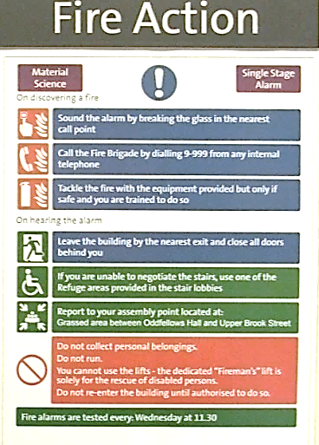

Buddy system
- In-person buddy, i.e. paired or group who arrive and leave together. Remember “safety in numbers”.
- Remote buddy to check in/out at regular intervals via phone, Apps, emails etc. If the worker does not respond at the pre-agreed time, escalate as per pre-agreed arrangement.
- Campus Security can be used for checking in/out, via the SafeZone app
Utilise technologies and carry a charged mobile phone
- SafeZone app - contact Campus Security quickly and discretely, including for first aid help.
- what3words– pinpoint exact street location to within 3m², generate a random 3-word combination which can then be shared with a trusted person, so they know where you are.
- My SafetiPin – GPS location tracking to identify the best routes and nearby safe spots.
- Emergency SOS – allow emergency call and a siren to be activated from the lock button on an iPhone.
- One Scream - voice activation to get help, trigger a siren and send automated message with the phone location to the designated contacts.
- bSafe – voice or touch activation of an SOS button, send automated recording of the surroundings to the designated contacts, ability to make a ‘fake call’ so the phone will ring to help the person leave a situation.
- Apps such as WhatsApp, Slack, Microsoft Teams can all be used for groups to check in/out with each other.

Other ways to get help
- Call Campus Security on 0161 3069966. Their number is on the back of your University ID card. Put this in your mobile phone.
- Call 999 in the event of a life-threatening emergency or if you or someone you are with requires immediate medical attention.
- In the Oxford Road area, “Manchester Safe Zones” have been set up for anyone being followed, feeling vulnerable or are unwell. All premises participating in the scheme have a ‘Safe Zone’ sticker on display in the window.
Options include wait for the problem to pass, call a taxi or get help from one of these businesses or they can call the police if required. Asda and Tesco have also promised that people can use their stores as a ‘safe space’ as they wait for a taxi, a friend or public transport.

Student support team provides free panic alarms to students. They can be collected from
- Reception at the Tower in Fallowfield (open 10am – 3pm, Monday to Friday)
- Main Library
- Alan Gilbert Learning Commons

In an undesired situation
- If you find yourself in an unsafe, uncomfortable, undesired situation, or something simply does not feel right, ACT immediately.
- Move away from the situation.
- Get yourself to a safe place. This can be a secure room within the building (e.g. an office that can be locked from the inside), or a public place with other people (e.g. supermarket, café, train station etc.)
- Get help – alert Campus Security, call 999 or ask people in the vicinity to help you.
- The following is a campaign from Counter Terrorism Policing. The same principle of “RUN, HIDE, TELL” can be applied to all unsafe situations.

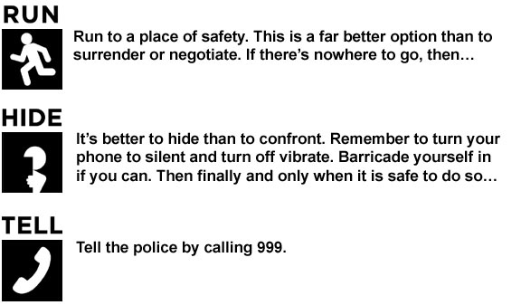

After an incident
- Always report an incident once it is safe to do so, even if there has been no harm to people or damage to property. This can be done via
- Campus Security on 0161 3069966
- Non-emergency police number on 111
- University Report and Support platform.
- Line manager or Academic Supervisor
- Faculty Safety Team fse.safety@manchester.ac.uk

Real examples on campus
A PhD student working during the day in a shared office had an unexpected seizure and collapsed onto the floor. Other students were able to call first aid help immediately. The student was taken to hospital and subsequently find out they had an un-diagnosed health condition.
A member of staff working alone in an office had a cardiac arrest. They had their office door open so was subsequently seen at their desk by colleagues passing by. An ambulance was called, and the person made a full recovery.
A PDRA entering a building in the evening with their swipe card noticed someone tailgating behind them. The PDRA went immediately to their lab, where other colleagues were present, and called Campus Security. Security staff came and checked the building for any suspicious activities.
A PhD student leaving work in the evening phoned their designated buddy to “check-out” as they were leaving the building. They were approached by a group who demanded the mobile phone, which the student handed over. Because they were speaking to their buddy at the time of the incident, the buddy heard what was happening and immediately called Campus Security, who were then able to attend the scene quickly to help the student and to report the crime.

Document Control
Document Title | FSE Guidance on Personal Safety during Lone Working and Out of Hours - Version 1.0
Document Owner | FSE Faculty Health, Safety and Wellbeing Committee
Document Author | Julia Cheung, Faculty Safety, Compliance & Risk Manager
Date Approved | 24 January 2022
Approved By | FSE Faculty Health, Safety and Wellbeing Committee
Review Date | January 2023 or if significant changes occur

